# Acropolis Institute Of Technology And Research,Indore(M.P.)



**Subject – Database Management System (DBMS)**

**CY-405**

**Name :- Tarun Kumar Makode**

**Enrollment No :- 0827CY221064**

**Branch :- CS (Cyber Security) Semester :- 4th (2nd year)**

**Submitted To :-Mrs. Nidhi Nigam Ma’am**

Index

|  |  |  |  |  |
| --- | --- | --- | --- | --- |
| **Sr.**  **No.** | **Experiment** | **Date of Exp.** | **Date of sub.** | **Grade** |
| 1. | To study DBMS and RDBMS, its characteristic comparisons and study of popular DB software. | 11/03/24 | 22/04/24 |  |
| 2. | Study of MySQL, Features of MySQL, Installation steps | 18/03/24 | 22/04/24 |  |
| 3. | Implementation of Database commands in MySQL (create database,show database,use database,drop  database) | 24/04/24 | 1/5/24 |  |
| 4. | Implementation of DDL commands in MySQL (create table ,alter table ,drop table) | 24/04/24 | 1/5/24 |  |
| 5. | Implementation of DML commands in MySQL  (Insert , Update ,Delete) | 24/04/24 | 1/5/24 |  |
|  |  |  |  |  |
|  |  |  |  |  |
|  |  |  |  |  |
|  |  |  |  |  |
|  |  |  |  |  |
|  |  |  |  |  |

|  |  |  |  |  |
| --- | --- | --- | --- | --- |
|  |  |  |  |  |

# Experiment -1

# Study of DBMS,RDMS and their comparison with lastest software that are available

## Introduction to DBMS :

A Database Management System (DBMS) is a software system that is designed to manage and organize data in a structured manner. It allows users to create, modify, and query a database, as well as manage the security and access controls for that database.

DBMS provides an environment to store and retrieve the data in coinvent and efficient manner.

DBMS manages the data, the database engine, and the database schema, allowing for data to be manipulated or extracted by users and other programs. This helps provide data security, data integrity, concurrency, and uniform data administration procedures.

DBMS optimizes the organization of data by following a database schema design technique called normalization, which splits a large table into smaller tables when any of its attributes have redundancy in values. DBMS offer many benefits over traditional file systems, including flexibility and a more complex backup system.

## Types of DBMS :

##### **Centralized Database**

A centralized database is basically a type of database that is stored, located as well as maintained at a single location and it is more secure when the user wants to fetch the data from the Centralized Database.

###### Advantages:

* 1. Data Security
  2. Reduced Redundancy
  3. Consistency

###### Disadvantages:

1. The size of the centralized database is large which increases the response and retrieval time.
2. It is not easy to modify, delete and update.

##### **Distributed Database**

Unlike a centralized database system, in distributed systems, data is distributed among different database systems of an organization. These database systems are connected via communication links. Such links help the end-users to access the data easily. **Examples** of the Distributed database are Apache Cassandra, HBase, Ignite, etc.

We can further divide a distributed database system into:

* **Homogeneous DDB:** Those database systems which execute on the same operating system and use the same application process and carry the same hardware devices.
* **Heterogeneous DDB:** Those database systems which execute on different operating systems under different application procedures, and carries different hardware devices.

##### **Relational Database**

This database is based on the relational data model, which stores data in the form of rows(tuple) and columns(attributes), and together forms a table(relation). A relational database uses SQL for storing, manipulating, as well as maintaining the data. E.F. Codd invented the database in 1970. Each table in the database carries a key that makes the data unique from others. Examples of Relational databases are MySQL, Microsoft SQL Server, Oracle, etc.

##### **NoSQL Database**

Non-SQL / Not Only SQL is a type of database that is used for storing a wide range of data sets. It is not a relational database as it stores data not only in tabular form but in several different ways. It came into existence when the demand for building modern applications increased. Thus, NoSQL presented a wide variety of database technologies in response to the demands.

##### **Cloud Database**

A type of database where data is stored in a virtual environment and executes over the cloud computing platform. It provides users with various cloud computing services (SaaS, PaaS, IaaS, etc.) for accessing the database. There are numerous cloud platforms, but the best options are:

* Amazon Web Services(AWS)
* Microsoft Azure
* Kamatera
* PhoenixNAP
* ScienceSoft
* Google Cloud SQL, etc.

##### **Object-oriented Databases**

The type of database that uses the object-based data model approach for storing data in the database system. The data is represented and stored as objects which are similar to the objects used in the object-oriented programming language.

##### **Hierarchical Databases**

It is the type of database that stores data in the form of parent-children relationship nodes. Here, it organizes data in a tree-like structure.

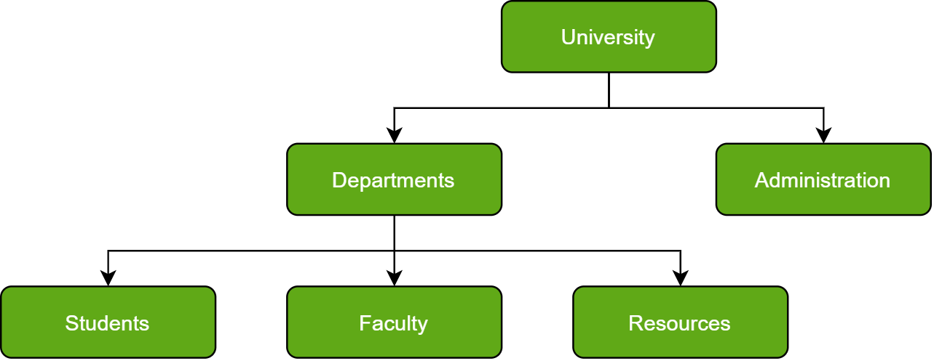

Data get stored in the form of records that are connected via links. Each child record in the tree will contain only one parent. On the other hand, each parent record can have multiple child records.

##### **Operational Database**

The type of database which creates and updates the database in real-time. It is basically designed for executing and handling the daily data operations in several businesses. For example, An organization uses operational databases for managing per day transactions.

##### **Network Database**

A network database is a hierarchical database, but with a major tweak. The child records are given the freedom to associate with multiple parent records. As a result, a network or net of database files linked with multiple threads is observed. A complex framework, network databases are more capable of representing two-directional relationships. Also, conceptual simplicity favors the utilization of a simpler database management language.

The disadvantage lies in the inability to alter the structure due to its complexity and also in it being highly structurally dependent.

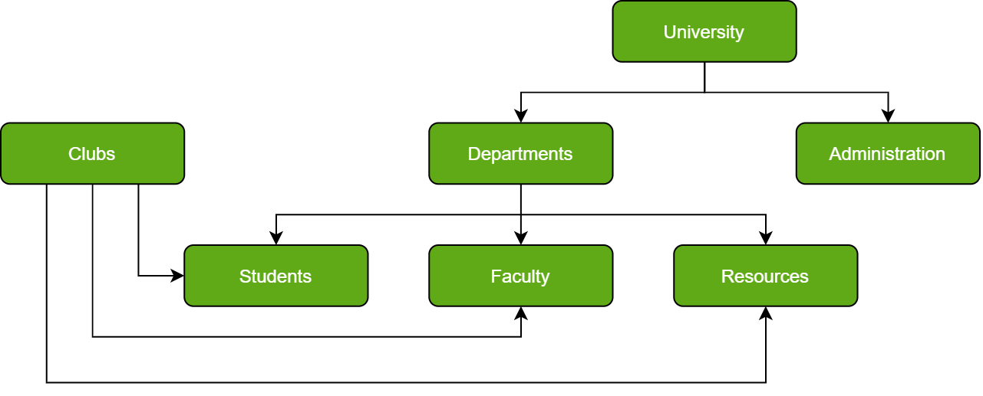

##### **Personal Database**

Collecting and storing data on the user's system defines a Personal Database. This database is basically designed for a single user.

## KEY FEATURES OF DBMS :

1. **Data Security**

Features of ER Model in DBMS - Data security is paramount in an era where data breaches and cyberattacks are rampant. DBMS provides robust mechanisms for securing sensitive information. Access control, authentication, and encryption are tools at its disposal. With DBMS, administrators can define who can access specific data, what actions they can perform, and when they can do it. This feature ensures that only authorised personnel can access and modify critical data.

1. **Data Integrity**

Data integrity ensures that data remains accurate and consistent throughout its lifecycle. DBMS enforces data integrity constraints, such as primary keys, foreign keys, and check constraints, preventing erroneous or inconsistent data insertion. This feature helps maintain data accuracy and reliability, which is vital for decision-making.

1. **Data Recovery**

Data loss can be catastrophic for businesses. DBMS offers additional features of the ER model in DBMS data recovery features, including backups and transaction logs. Backups allow organizations to restore data to a previous state in case of hardware failure or data corruption. Transaction logs record all changes to the database, enabling point-in-time recovery. These features of DBMS ensure data continuity and minimize downtime.

1. **Concurrency Control**

In multi-user environments, simultaneous access to the database can lead to conflicts and inconsistencies. DBMS employs concurrency control mechanisms to manage concurrent transactions effectively. Techniques like locking and timestamp-based protocols ensure that multiple users can work on the same data without interfering with each other.

1. **Query Language**

Features of SQL in DBMS - Users need a way to communicate their requests to interact with a database. DBMS provides a standardised query language, such as SQL (Structured Query Language), which allows users to retrieve, update, and manipulate data in a database. SQL is a powerful tool that enables complex data operations with ease.

1. **Scalability**

As organisations grow, their data requirements expand exponentially. DBMS offers scalability features to accommodate this growth. DBMS can adapt to changing data needs, whether horizontal scaling (adding more servers) or vertical scaling (upgrading hardware), ensuring optimal performance.

1. **Data Redundancy Control**

Data redundancy can lead to inconsistencies and wasted storage space. DBMS minimises redundancy by using normalisation techniques, which organise data in a

way that reduces duplication. This not only saves storage space but also enhances data consistency.

1. **ACID Properties**

The foundation of database transactions is the ACID properties (Atomicity, Consistency, Isolation, and Durability). DBMS ensures that transactions are atomic (indivisible), consistent (follow defined rules), isolated (do not interfere with each other), and durable (persist even after system failures). These properties guarantee data reliability and maintain the integrity of the database.

1. **Indexing**

Efficient data retrieval is crucial for performance. DBMS uses indexing to create data structures that allow for rapid data access. Indexes provide a roadmap to the data, reducing the time needed to retrieve information. They are essential for speeding up search operations in large databases.

1. **Data Compression and Storage Optimization**

In a world where data storage costs can skyrocket, features of DBMS for data compression and storage optimisation. This reduces storage expenses and improves query performance by reducing the amount of data that needs to be processed.

1. **Data Backup and Recovery**

Data is the lifeblood of any organisation, and losing it can be catastrophic. DBMS systems have robust backup and recovery mechanisms to protect data. Regular backups and recovery plans safeguard data against hardware failures, human errors, and cyberattacks.

## Application of DBMS:

1. **Railway And Airline Reservation System**

The database keeps a record of ticket booking, arrival time, departure time, delays, and even seat numbers of airplanes or trains.

1. **Library Management System**

There can be tens of thousands of books in a library, so it becomes very important to keep a record of the details of each book. Handwritten records can prove to be a real hassle when managing literally thousands of books. DBMS comes into play here, all the details of each book - name, author, number of pages, availability, quantity, etc., can be managed using a Database Management System.

1. **Banking**

An uncountable number of bank transactions and deposits are made, thousands of new bank accounts are created daily, and many such things. This is all possible because of a Database Management System that makes keeping track of the record much easier.

1. **Education Sector (Schools and Colleges)**

The details of each student, teacher, and even janitor are stored in a database to manage the information easily.

1. **Social Media Sites (Instagram, Facebook, etc.)**

Social media websites like Instagram, Facebook, Whatsapp, etc., are able to keep track of each and every detail of their users (name, phone number, photos, email address, password, etc.) with the help of Database Management Systems.

1. **Online Shopping (E-commerce Platforms Like Amazon)**

With time, more and more people have started shopping online, no one wants to go to a shop and waste their time when they can do the same thing while at home and save time. With the increase in online shopping customers, there's a need to store their details efficiently.

That is why, all the details of the customers, products as well as order and tracking details are stored and managed using a Database Management System.

## RDBMS :

A Relational Database Management System (RDBMS) is a type of database management system that organizes data into tables, or "relations," which can be linked—or related—based on data common to each. This model of database management is the most prevalent today, largely because of its flexibility, efficiency, and scale, as well as the widespread use of SQL (Structured Query Language), which is used to manage and manipulate the data.

## Key features of RDBMS:

* 1. **Table-based Structure:** Data is stored in tables, which are similar to spreadsheets in that data is organized in rows and columns. Each row represents a single, implicitly structured data item known as a record, and each column represents a specific field within the record.
  2. **Data Manipulation:** SQL is the standard language used for inserting, updating, deleting, and querying data in RDBMS. SQL provides a powerful and flexible means to execute complex queries to manipulate and retrieve data.
  3. **Data Integrity:** Various data integrity rules ensure the accuracy and reliability of the data. This includes primary keys, foreign keys, and other constraints that ensure the accuracy and consistency of data across different tables.
  4. **Normalization:** This is a process of organizing data to reduce redundancy and improve data integrity. Normalization involves dividing large tables into smaller (and less redundant) tables and defining relationships between them.
  5. **ACID Properties:** RDBMS supports transactions that bring the database from one valid state to another. Transactions in an RDBMS follow the ACID properties (Atomicity, Consistency, Isolation, Durability), which guarantee that all transactions are processed reliably and ensure the integrity of data within the database.
  6. **Scalability and Performance:** RDBMS systems are designed to handle large amounts of data and support numerous concurrent users. Performance tuning options, such as indexing and caching, enhance query performance and scalability.
  7. **Security:** RDBMS systems provide comprehensive security measures, such as user authentication, authorization, and encrypted communication, to protect sensitive data from unauthorized access.

## Popular RDBMS Software:

* + - Oracle Database: Known for its feature richness, robustness, and high scalability options, Oracle Database is a leader in the enterprise database market.
    - MySQL: An open-source RDBMS, very popular in the web hosting industry, often used in the LAMP (Linux, Apache, MySQL, PHP/Python/Perl) stack.
    - Microsoft SQL Server: Known for its integration with other Microsoft products and services, making it a preferred choice for organizations heavily invested in the Microsoft ecosystem.
    - PostgreSQL: An open-source RDBMS, known for its standards compliance and extensibility. PostgreSQL supports both SQL (relational) and JSON (non-relational) querying.
    - IBM DB2: Used primarily by large enterprises for mission-critical applications, offering robust data management and analytics capabilities.

**Difference between DBMS & RDBMS:**

|  |  |
| --- | --- |
| **DBMS** | **RDBMS** |
| Data is stored in a database management system (DBMS) as a file | Tables are used to store information |
| Data is stored in a database management system (DBMS) in either a navigational or  hierarchical format | RDBMS employs a tabular format, with column names as headers and  associated data as rows |
| Only a single user is supported by the DBMS | It may be used by numerous people |
| The data in a typical database may not be stored according to the ACID model  This can lead to database discrepancies | Relational databases are more difficult to create, but they are more consistent and organised  They follow the rules of ACID (Atomicity, Consistency, Isolation, Durability) |
| It is an application that is used to manage databases over computer networks as well as the system hard drives | The database systems are used to keep track of the relationships between the tables |
| Software and hardware requirements are minimal | Higher hardware and software requirements are required |
| The integrity constraints are not supported by DBMS  At the file level, the integrity constraints are not imposed | At the schema level, RDBMS provides integrity restrictions  Values outside of a certain range cannot be stored in the RDBMS column |
| Normalization is not supported by DBMS. | A relational database management system (RDBMS) can be normalized. |
| Distributed databases are not supported by DBMS | Distributed databases are supported by RBMS |
| The DBMS system is mostly used to manage tiny amounts of data | The RDBMS database is built to manage a vast volume of data |

|  |  |
| --- | --- |
| Dbms only meet seven of Dr E.F. Codd’s  rules | Dbms meet 8 to 10 of Dr E.F. Codd’s  rules |
| Client-server architecture is not supported by DBMS | Client-server architecture is supported by RDBMS |
| For complicated and vast amounts of data, data retrieval takes longer | Because of its relational methodology, data retrieval is quick |
| In this architecture, data redundancy is common | Data redundancy is not possible using keys and indexes |
| There is no correlation between the data | Data is kept in the form of tables that are linked together via foreign keys |
| There is no sense of safety | Multiple security levels are available. At the OS, command, and object levels,  log files are produced |
| Individual data items must be accessed | SQL queries make it simple to retrieve data.At the same time, many data items can be accessed |
| A file system, XML, the Windows Registry, and other DBMS are examples | MySQL, Oracle, SQL Server, and other RDBMS are examples |

# Experiment -2

## Study of MySQL, Features & Installation steps

**MySQL**

MySQL is an open-source relational database management system (RDBMS) that facilitates the management and retrieval of structured data using SQL (Structured Query Language). Since its inception in 1995 by Michael Widenius and David Axmark, MySQL has grown to become one of the most popular RDBMS in the world, particularly for web applications. Here is a detailed introduction to MySQL, covering its history, architecture, features, and uses.

MySQL is a relational database management system.

[Databases](https://www.oracle.com/in/database/what-is-database/) are the essential data repository for all software applications. For example, whenever someone conducts a web search, logs in to an account, or completes a transaction, a database system is storing the information so it can be accessed in the future.

A [relational database](https://www.oracle.com/in/database/what-is-a-relational-database/) stores data in separate tables rather than putting all the data in one big storeroom.

Open source means it’s possible for anyone to use and modify the software. Anybody can download MySQL software from the internet and use it without paying for it. You can also change its source code to suit your needs. MySQL software uses the GNU General Public License (GPL) to define what you may and may not do with the software in different situations.

## MySQL Benefits:

MySQL is fast, reliable, scalable, and easy to use. It was originally developed to handle large databases quickly and has been used in highly demanding production environments for many years.

* Ease of use: Developers can install MySQL in minutes, and the database is easy to manage.
* Reliability: MySQL is one of the most mature and widely used databases. It has been tested in a wide variety of scenarios for more than 25 years,

including by many of the world’s largest companies. Organizations depend on MySQL to run business-critical applications because of its reliability.

* Scalability: MySQL scales to meet the demands of the most accessed applications. MySQL’s native replication architecture enables organizations such as Facebook to scale applications to support billions of users.
* Performance: MySQL HeatWave is faster and less expensive as demonstrated by multiple standard industry benchmarks, including TPC-H, TPC-DS, and CH-benCHmark
* High availability: MySQL delivers a complete set of native, fully integrated replication technologies for high availability and disaster recovery. For business-critical applications, and to meet service-level agreement commitments, customers can achieve

Recovery point objective = 0 (zero data loss)

Recovery time objective = seconds (automatic failover)

* Security: Data security entails protection and compliance with industry and government regulations, including the European Union General Data Protection Regulation, the Payment Card Industry Data Security Standard, the Health Insurance Portability and Accountability Act, and the Defense Information Systems Agency’s Security Technical Implementation Guides. MySQL Enterprise Edition provides advanced security features, including authentication/authorization, transparent data encryption, auditing, data masking, and a database firewall.
* Flexibility: The MySQL Document Store gives users maximum flexibility in developing traditional SQL and NoSQL schema-free database applications. Developers can mix and match relational data and JSON documents in the same database and application.

## MySQL use cases:

* Ecommerce: Many of the world’s largest ecommerce applications (for example, Shopify, Uber, and Booking.com) run their transactional systems on MySQL. It’s a popular choice for managing user profiles, credentials, user content, financial data including payments, and fraud detection.
* Social platforms: Facebook, Twitter, and LinkedIn are among the world’s largest social networks that rely on MySQL.
* Content management: Unlike single-purpose document databases, MySQL enables both SQL and NoSQL with a single database. The MySQL Document Store enables CRUD operations and the power of SQL to query data from JSON documents for reporting and analytics.
* SaaS and ISVs: More than 2,000 ISVs, OEMs, and VARs, including Ericsson, F5, and IBM, rely on MySQL as their embedded database to make their applications, hardware, and appliances more competitive, bring them to market faster, and lower their cost of goods sold. MySQL is also the database behind popular SaaS applications, including Zendesk and HubSpot.
* Other popular applications using MySQL include ones for online gaming, digital marketing, retail point-of-sale systems, and Internet of Things monitoring systems.
* Cloud applications: MySQL is very popular in the cloud. MySQL HeatWave is a fully managed database service, powered by the integrated HeatWave

in-memory query accelerator. It’s the only cloud database service that combines transactions, real-time analytics across data warehouses and data lakes, and machine learning (ML) services into one MySQL Database—without the complexity, latency, cost, and risk of ETL duplication. With MySQL HeatWave AutoML, developers and data analysts can build, train, deploy, and explain machine learning models within MySQL HeatWave in a fully automated way.

**SS of default my sql command:**

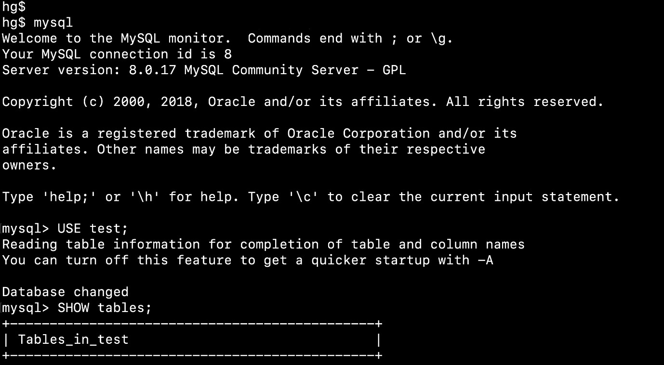

## STUDY OF MYSQL :

**How MySQL Works?**

MySQL follows the working of Client-Server Architecture. This model is designed for the end-users called clients to access the resources from a central computer known as a server using network services. Here, the clients make requests through a graphical user interface (GUI), and the server will give the desired output as soon as the instructions are matched. The process of MySQL environment is the same as the client-server model.

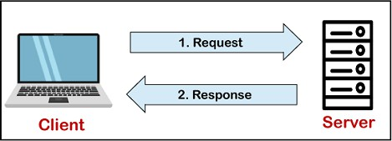

The core of the MySQL database is the MySQL Server. This server is available as a separate program and responsible for handling all the database instructions, statements, or commands. The working of MySQL database with MySQL Server are as follows:

1. MySQL creates a database that allows you to build many tables to store and manipulate data and defining the relationship between each table.
2. Clients make requests through the GUI screen or command prompt by using specific SQL expressions on MySQL.
3. Finally, the server application will respond with the requested expressions and produce the desired result on the client-side.

A client can use any MySQL [GUI](https://www.javatpoint.com/gui-full-form). But, it is making sure that your GUI should be lighter and user-friendly to make your data management activities faster and easier. Some of the most widely used MySQL GUIs are MySQL Workbench, SequelPro, DBVisualizer, and the Navicat DB Admin Tool. Some GUIs are commercial, while some are free with limited functionality, and some are only compatible with MacOS. Thus, you can choose the GUI according to your needs.

## MySQL Features

MySQL is a relational database management system (RDBMS) based on the SQL (Structured Query Language) queries. It is one of the most popular languages for accessing and managing the records in the table. MySQL is open-source and free software under the GNU license. Oracle Company supports it.

The following are the most important features of MySQL:

## Relational Database Management System (RDBMS)

[MySQL](https://www.javatpoint.com/mysql-tutorial) is a relational database management system. This database language is based on the [SQL](https://www.javatpoint.com/sql-tutorial) queries to access and manage the records of the table.

1. **Easy to use** - MySQL is easy to use. We have to get only the basic knowledge of SQL. We can build and interact with MySQL by using only a few simple SQL statements.
2. **It is secure** - MySQL consists of a solid data security layer that protects sensitive data from intruders. Also, passwords are encrypted in MySQL.
3. **Client/ Server Architecture -** MySQL follows the working of a client/server architecture. There is a database server (MySQL) and

arbitrarily many clients (application programs), which communicate with the server; that is, they can query data, save changes, etc.

1. **Free to download -** MySQL is free to use so that we can download it from MySQL official website without any cost.
2. **It is scalable** - MySQL supports multi-threading that makes it easily scalable. It can handle almost any amount of data, up to as much as 50 million rows or more. The default file size limit is about 4 GB. However, we can increase this number to a theoretical limit of 8 TB of data.
3. **Speed** - MySQL is considered one of the very fast database languages, backed by a large number of the benchmark test.
4. **High Flexibility** - MySQL supports a large number of embedded applications, which makes MySQL very flexible.
5. **Compatible on many operating systems** - MySQL is compatible to run on many operating systems, like Novell NetWare, Windows* Linux*, many varieties of UNIX* (such as Sun* Solaris*, AIX, and DEC* UNIX), OS/2, FreeBSD*, and others. MySQL also provides a facility that the clients can run on the same computer as the server or on another computer (communication via a local network or the Internet).
6. **Allows roll-back** - MySQL allows transactions to be rolled back, commit, and crash recovery.
7. **Memory efficiency** - Its efficiency is high because it has a very low memory leakage problem.
8. **High Performance** - MySQL is faster, more reliable, and cheaper because of its unique storage engine architecture. It provides very high-performance results in comparison to other databases without losing an essential functionality of the software. It has fast loading utilities because of the different cache memory.
9. **High Productivity** - MySQL uses Triggers, Stored procedures, and views that allow the developer to give higher productivity.
10. **Platform Independent** - It can download, install, and execute on most of the available operating systems.
11. **Partitioning** - This feature improves the performance and provides fast management of the large database.
12. **GUI Support** - MySQL provides a unified visual database graphical user interface tool named "**MySQL Workbench**" to work with database architects, developers, and Database Administrators. [MySQL](https://www.javatpoint.com/mysql-workbench) [Workbench](https://www.javatpoint.com/mysql-workbench) provides SQL development, data modeling, data migration, and comprehensive administration tools for server configuration, user administration, backup, and many more. MySQL has a fully GUI supports from MySQL Server version 5.6 and higher.
13. **Dual Password Support** - MySQL version 8.0 provides support for dual passwords: one is the current password, and another is a secondary password, which allows us to transition to the new password.

## Disadvantages/Drawback of MySQL

Following are the few disadvantages of MySQL:

* + MySQL version less than 5.0 doesn't support ROLE, COMMIT, and stored procedure.
  + MySQL does not support a very large database size as efficiently.
  + MySQL doesn't handle transactions very efficiently, and it is prone to data corruption.
  + MySQL is accused that it doesn't have a good developing and debugging tool compared to paid databases.
  + MySQL doesn't support SQL check constraints.

### MySQL Installation on Windows:

Here we will show you step by step how to install MySQL on the Windows platform using the MySQL Installer.

### Download MySQL

The simplest and recommended method is to download MySQL Installer for Windows from <https://dev.mysql.com/downloads/installer/> and execute it.

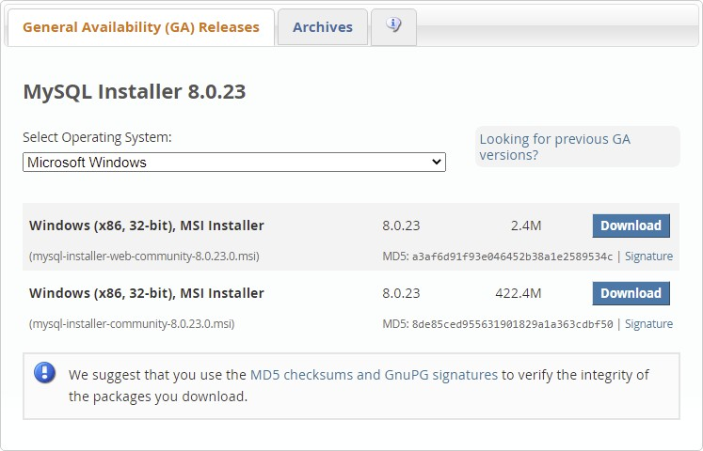

Select mysql-installer-web-community-8.0.23.msi if you have good internet connection, otherwise choose mysql-installer-community-8.0.23.msi.

### Install MySQL

After downloading, unzip it, and double click the MSI installer .exe file. Then follow the steps below:

1. **"Choosing a Setup Type"** screen: Choose "Full" setup type. This installs all MySQL products and features. Then click the "Next" button to continue.
2. **"Check Requirements"** screen: The installer checks if your pc has the requirements needed. If there is some failing requirements, click on each item to try to resolve them by clicking on the Execute button that will install all requirements automatically. Click "Next".
3. **"Installation"** screen: See what products that will be installed. Click "Execute" to download and install the Products. After finishing the installation, click "Next".
4. **"Product Configuration"** screen: See what products that will be configured. Click the "MySQL Server 8.0.23" option to configure the MySQL Server. Click the "Next" button. Choose the "Standalone MySQL Server/Classic MySQL Replication" option and click on the "Next" button. In page "Type and Networking" set Config Type to "Development Computer" and "Connectivity" to "TCP/IP" and "Port" to "3006". Then, click the "Next" button.
5. **"Authentication Method"** screen: Choose "Use Strong Password Encryption for Authentication". Click "Next".
6. **"Accounts and Roles"** screen: Set a password for the root account. Click "Next".
7. **"Windows Service"** screen: Here, you configure the Windows Service to start the server. Keep the default setup, then click "Next".
8. **"Apply Configuration"** screen: Click the "Execute" button to apply the Server configuration. After finishing, click the "Finish" button.
9. **"Product Configuration"** screen: See that the Product Configuration is completed. Keep the default setting and click on the "Next" and "Finish" button to complete the MySQL package installation.
10. In the next screen, you can choose to configure the Router. Click on "Next", "Finish" and then click the "Next" button.
11. **"Connect To Server"** screen: Type in the root password (from step 6). Click the "Check" button to check if the connection is successful or not. Click on the "Next" button.
12. **"Apply Configuration"** screen: Select the options and click the "Execute" button. After finishing, click the "Finish" button.
13. **"Installation Complete"** screen: The installation is complete. Click the "Finish" button.

###### Verify MySQL Installation

Open the **MySQL Command Line Client** from cmd.

You should see a mysql> prompt. If you have set any password, write your password here.

Now, you are connected to the MySQL server, and you can execute all the SQL command at mysql> prompt as follows:

For example: Check the already created databases with show databases command:

# Experiment -3

**Study of basic commands in MYSQL**

#### Basic Commands:

* 1. **CREATE DATABASE -** This statement is used to create a new SQL database.

**SYNTAX:** CREATE DATABASE *databasename*; Example-

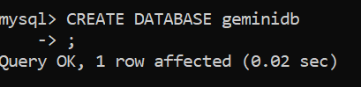

* 1. **SHOW DATABASE -** This statement is used to display SQL databases.

**SYNTAX:** SHOW DATABASES;

Example-

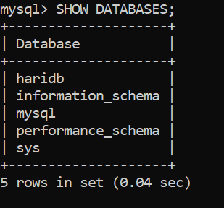

* 1. **DROP DATABASE -** This statement is used to drop an existing SQL database.

**SYNTAX:** DROP DATABASE *databasename*; Example-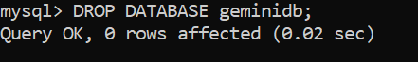

* 1. **USE DATABASE -** The use statement selects a specific database and then performs operations on it using the inbuilt commands of SQL.

**SYNTAX:** USE *databasename*; Example-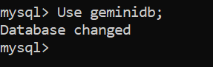

# Experiment - 4

**Study of DDL commands in MYSQL**

DDL (Data Definition Language) is a type of SQL command used to define data structures and modify data. It creates, alters, and deletes database objects such as tables, views, indexes, and users. Examples of DDL statements include CREATE, ALTER, DROP and TRUNCATE.

Snega is a talented programmer who has been eager to learn more about the various aspects of Python programming. One day, she comes across a tutorial about databases and SQL queries. She is particularly interested in learning about the basics of databases, such as Data Definition Language (DDL) and Data Manipulation Language (DML). She eagerly starts reading the tutorial. Lets help her in the journey.

CREATE: It is used to create objects in the database, such as tables, views, stored procedures, and more.

ALTER: It is used to modify the structure of an existing database object.

DROP: It is used to delete an entire object or part of an object from the database.

TRUNCATE: Used to delete all records from a table but does not delete the table structure.

RENAME: Used to rename an existing database object.

#### Basic Commands:

1. **CREATE TABLE -** This statement is used to create a new table in a database.

**SYNTAX:** CREATE TABLE *table_name* ( column1 *datatype*,

column2 *datatype*, column3 *datatype*,

....

);

Example-

1. **ALTER TABLE -** This statement is used to add, delete, or modify columns in an existing table.

**SYNTAX:** ALTER TABLE table_name ADD column_name datatype;

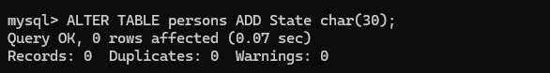Example-

1. **DROP TABLE** - This statement is used to drop an existing table in a database.

**SYNTAX:** DROP TABLE table_name; Example-



1. **SHOW TABLES -** This statement is used to display all the tables present in a particular database.

**SYNTAX:** SHOW TABLES;

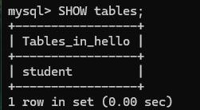Example-

# Experiment - 5

**Study DML commands in MYSQL**

DML (Data Manipulation Language) is a type of SQL command used to manipulate data in a database. It inserts, updates, and deletes data from a database table. Examples of DML statements include INSERT, UPDATE, and DELETE.

INSERT: Used to add new records to a database table. UPDATE: Used to modify existing records in a database table. DELETE: Used to delete existing records from a database table.

MERGE: Used to combine data from two or more tables into one. SELECT: Used to retrieve data from one or more tables in a database. CALL: Used to call a stored procedure or function.

#### Basic Commands:

1. **INSERT INTO -** This statement is used to insert new records in a table.

**SYNTAX:** INSERT INTO *table_name* (column1, column2, column3, ...) VALUES (value1, value2, value3, ...);

Example-

1. **SELECT * -** If you want to return all columns, without specifying every column name, you can use this statement.

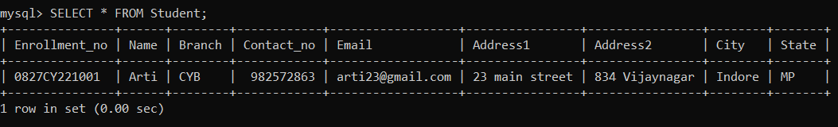**SYNTAX:** SELECT * FROM *table_name*; Example-

1. **UPDATE** - This statement is used to modify the existing records in a table.

**SYNTAX:** UPDATE *table_name*

SET *column1 = value1, column2 = value2, ...*

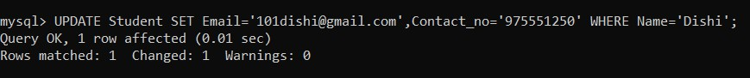WHERE *condition*; Example -

1. **DELETE** - This statement is used to delete existing records in a table.

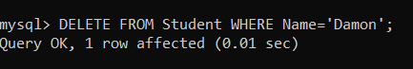**SYNTAX:** DELETE FROM *table_name* WHERE *condition*; Example -